What is the use of “System.in.read()”?

|  |
| --- |
| It (read method) reads a single character from keyboard and gives us the unicode(ASCII) value of a character. |

If you got the below type of error while compilation you have to throw that exception out of the present method by using throws keyword.

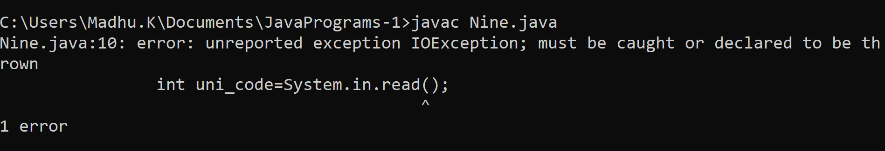

Example on read() method

|  |
| --- |
| /*  Program: to read a single character from keyboard  */  import java.lang.*;  class Nine  {  //Naming convention of a class: Every word first letter capital  public static void main(String args[])throws Exception  { System.out.print("Enter any character:\t");  int uni_code=System.in.read();  System.out.println("Unicode value of Given Character:\t"+uni_code);  }  }  Output:  C:\Users\Madhu.K\Documents\JavaPrograms-1>java Nine  Enter any character:  Unicode value of Given Character: 32  C:\Users\Madhu.K\Documents\JavaPrograms-1>java Nine  Enter any character:  Unicode value of Given Character: 13  C:\Users\Madhu.K\Documents\JavaPrograms-1>java Nine  Enter any character: &  Unicode value of Given Character: 38  C:\Users\Madhu.K\Documents\JavaPrograms-1>java Nine  Enter any character: madhu  Unicode value of Given Character: 109 |

Nine.java

|  |
| --- |
| /*  Program: to read input from keyboard by using read() method  */  import java.lang.*;  class Nine  {  static String input()throws Exception  {  String line="";  //line=""  System.out.print("Enter any character:\t");  int uni_code=0;  while( (uni_code=System.in.read()) !=13 )  {  char ch=(char)uni_code;  line=line+ch; //"madh"+'u'  //1=> line="madhu"  }  return line;  }  public static void main(String args[])throws Exception  {  String s1=input();  System.out.println("Given input is:\t"+s1);    }  }  Output:  C:\Users\Madhu.K\Documents\JavaPrograms-1>javac Nine.java  C:\Users\Madhu.K\Documents\JavaPrograms-1>java Nine  Enter any character: madhu  Given input is: madhu |

Program on reading a line(string) from keyboard using user-defined function

|  |
| --- |
| /*  Program: to read input from keyboard by using read() method  */  import java.lang.*;  class Nine  {  static String input(String outputStr)throws Exception  {  String line="";  //line=""  System.out.print(outputStr);  int uni_code=0;  while( (uni_code=System.in.read()) !=13 )  {  //System.out.println("unicode="+uni_code);  if(uni_code!=10)  {  char ch=(char)uni_code;  line=line+ch; //"madh"+'u'  }  //1=> line="madhu"  }  //System.out.println("size="+line.length());  return line;  }  public static void main(String args[])throws Exception  {  String name=input("Enter Your Name:\t");  System.out.println("Name:\t"+name);  String city=input("Enter City:\t");  System.out.println("City:\t"+city);    }  }  Output: |